


What's On Guide
October - December 2015

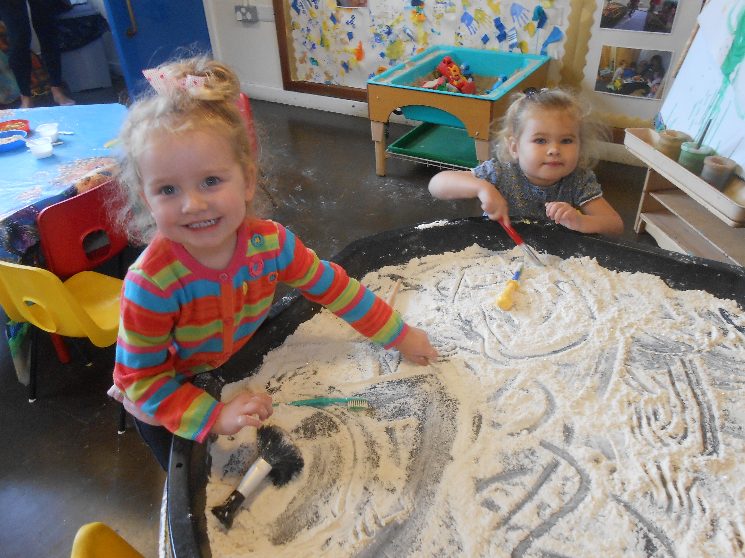

at
Locality 1 and 5 Children’s Centres
Delivering high quality Early Years services to all children under five and their families

All Children’s Centre activities in this locality are free of charge. However, voluntary donations are welcome.
Any donations received go back into providing resources for children and families within your local area.

Derwent Family, Youth and Community Centre, Monmouth Street, Derby DE21 6BD
Tel: 01332 385321 derwent.childrenscentre@derby.gov.uk

Derwent Family, Youth and Community Centre

Please call 01332 385321 where booking is needed

DAY | TIME | GROUP | VENUE | ADDITIONAL INFORMATION
Monday | 9.30 – 11am | New: Messy Play | Derwent Family Centre | From 14 September to 19 October
Monday | 10.30-11.30 | New: Baby Massage | Derwent Family Centre | 2, 9, 16, and 23 November  Contact Lisa Jackson on 01332 288760  to book places
Tuesday | 9.30 – 11am | Peep Learning Together  (Term time only) | Derwent Community School | Referral/limited places. Please speak to a member of staff for more information
Wednesday | 9.30 – 11am | Stay and Play | Derwent Family Centre | Runs weekly
Thursday | 9.30 – 11.30am | Child Health Clinic | Derwent Community School | Derwent Health Team can be contacted on  Tel: 01332 288760
Thursday | 10 – 11.30am | New: Multi Sports Activity | Derwent Family Centre | From 1 October
Thursday | 3.30 – 4.30pm | Tea Club | Derwent Family Centre | Please ring to book  Term time only
Monday - Thursday | 8.30am – 4.30pm | Toy loan service | Derwent Family Centre | Please ring the centre for further details

Derwent Family Centre is open Monday, Tuesday, Wednesday and Thursday 8.30am – 4.30pm.On a Friday please contact Audrey Drive Children's Centre on 01332 670634.

Sure Start Mackworth/Morley Children's Centre, Reigate Drive, Mackworth, Derby, DE22 4EQ Tel: 01332 208175
mackworth.childrenscentre@derby.gov.uk

Mackworth/Morley Children's Centre
Please ring 01332 208175 where booking is needed.

DAY | TIME | GROUP | VENUE | ADDITIONAL INFORMATION
Monday | 1 – 2.30pm | Child Health Clinic | Mackworth/Morley Children's Centre | Kingsmead Health Team can be contacted on  Tel: 01332 888112
Tuesday | 9.30-11.30am | New: Maths Course | Mackworth/Morley Children's Centre | From 29 September. Please ring to book.  Limited FREE crèche places available
Tuesday | 10 – 11.15am | Tuesday Trek | Mackworth/Morley Children's Centre | Term time only
Tuesday | 1.30 – 3pm | Once Upon A Rhyme | Ashgate Nursery | Term time only
Wednesday | 9.15 – 11.15am | Stay and Play | Ashgate Nursery | Term time only
Wednesday | 9.30 – 11am | Peep Learning Together  (Term time only) | Mackworth/Morley Children's Centre | Referral/limited places. Please speak to a member of staff for more information
Wednesday | 1.30 – 3pm | New: Messy Play | Mackworth/Morley Children's Centre | From 30 September. Please ring to book.
Thursday | 9.15 – 11.15am | Stay and Play | Mackworth/Morley Children's Centre | Please ring to book
Thursday | 1 – 2pm | Breastfeeding Club | Mackworth/Morley Children's Centre | The Infant Feeding Team can be contacted on  Tel: 01332 888121
Thursday | 2 – 3.30pm | Bumps and Babies | Mackworth/Morley Children's Centre | Runs weekly.
Monday – Friday | 9am – 5pm | Toy loan service | Mackworth/Morley Children's Centre | Please ring the centre for further details
Mackworth/Morley Children's Centre is open Monday to Friday 9am – 5pm.

Audrey Drive Children's Centre

Please ring 01332 670634 where booking is needed.

DAY | TIME | GROUP | VENUE | ADDITIONAL INFORMATION
Monday | 10am – 12noon | Home Birth Derby | Audrey Drive Children’s Centre | Running on 12 October, 9 November and 14 December only
Monday | 1.30 – 2.30pm | New: Baby Massage | Audrey Drive Children’s Centre | 5, 12, 19 and 26 October. Contact Lisa Jackson on 01332 288760 to book places
Tuesday | 9.30 – 11am | Peep Learning Together  (Term time only) | Audrey Drive Children's Centre | Referral/limited places. Please speak to a member of staff for more information
Tuesday | 1.30 – 3pm | Child Health Clinic | Audrey Drive Children's Centre | Chaddesden Health Team can be contacted on Tel: 01332 288774
Wednesday | 9.15am – 12.15pm | Childminder’s Group | Audrey Drive Children's Centre | Runs weekly
Wednesday | 1.30 – 2.45pm | Boys Play | Audrey Drive Children’s Centre | Please ring to book  Please note, this is for boys under 5 only
Wednesday | 3.30 – 4.30pm | New: Tea Club | Audrey Drive Children's Centre | Please ring to book  Term time only
Thursday | 10 – 11.30am | Baby and Toddler Group | Audrey Drive Children's Centre | Runs weekly
Thursday | 1 – 2pm | Breastfeeding Club | Audrey Drive Children's Centre | The Infant Feeding Team can be contacted on  Tel: 01332 888121
Thursday | 2 – 3.30pm | Bumps and Babies | Audrey Drive Children's Centre | Runs weekly
Friday | 9.30 – 11.30am | Stay and Play | Audrey Drive Children's Centre | Runs weekly
Saturday | 10 – 11.30am | Dad's group | Audrey Drive Children's Centre | 31 October and 28 November only
Monday - Friday | 9am – 5pm | Toy loan service | Audrey Drive Children's Centre | Please ring the centre for further details
Audrey Drive Children's Centre is open Monday to Friday 9am – 5pm

Audrey Drive Children's Centre, Audrey Drive, Chaddesden, Derby, DE21 4NP Tel: 01332 670634
Chaddesden.childrenscentres@derby.gov.uk

Oakwood Children's Centre, Springwood Drive, Oakwood, Derby, DE21 2RQ Tel: 01332 831965
oakwood.childrenscentre@derby.gov.uk

Oakwood Children's Centre

Please ring 01332 831965 where booking is needed.

DAY | TIME | GROUP | VENUE | ADDITIONAL INFORMATION
Monday | 10 – 11.30am | Childminder’s Group | Oakwood Children's Centre | Runs weekly
Monday | 1.30 – 3pm | Stay and Play | Oakwood Children's Centre | Runs weekly
Tuesday | 1.30 – 3pm | Child Health Clinic | Springwood Leisure Centre | Spondon/Oakwood Health Team can be contacted on  Tel: 01332 868838
Wednesday | 1 – 2.30pm | Bumps and Babies | Oakwood Children's Centre | Runs weekly. Please ring to book.
Monday, Wednesday  and Friday | 9am – 3pm | Toy loan service | Oakwood Children's Centre | Please ring the centre for further details

Oakwood Children's Centre is open Monday, Wednesday and Friday 9am – 3pm.
Please contact Audrey Drive Children's Centre on 01332 670634 outside of these hours.

Meadow Lane Children's Centre, Meadow Lane, Chaddesden, Derby, DE21 6PB Tel: 01332 671591
chaddesden.childrenscentres@derby.gov.uk

Meadow Lane Children's Centre

Please ring 01332 671591 where booking is needed.

DAY | TIME | GROUP | VENUE | ADDITIONAL INFORMATION
Monday | 10 – 11.30am | Baby and Toddler Group | Meadow Lane Children's Centre | Runs weekly. Limited places available.
Tuesday | 1.15 – 2.45pm | Stay and Play | Meadow Lane Children's Centre | Runs weekly
Wednesday | 1.30 – 3pm | Stay and Play | Chesapeake Community Centre | Runs weekly
Thursday | 9.30 – 11am | Peep Learning Together  (Term time only) | Meadow Lane Children's Centre | Please ring to book. Please speak to a member of staff for more information
Thursday | 1.15 – 2.45pm | Once Upon A Rhyme | Meadow Lane Children's Centre | Runs weekly. Please ring to book.
Monday, Tuesday and Thursday | 9am – 3pm | Toy loan service | Meadow Lane Children's Centre | Please ring the centre for further details

Meadow Lane Children's Centre is open Monday, Tuesday and Thursday 9am – 3pm.
Please contact Audrey Drive Children's Centre on 01332 670634 outside of these hours.

Spondon Children's Centre, Borrowash Road, Spondon, Derby, DE21 7PH Tel: 01332 662323 (option 2)
spondon.childrenscentre@derby.gov.uk

Spondon Children's Centre
Please ring 01332 662323 (option 2) where booking is needed

DAY | TIME | GROUP | VENUE | ADDITIONAL INFORMATION
Monday | 1.30 – 3pm | Child Health Clinic | Spondon Children's Centre | Spondon/Oakwood Health Team can be contacted on Tel: 01332 868838
Tuesday | 9.30 – 11.30am | Childminder’s Group | Spondon Children's Centre | Runs fortnightly
Wednesday | 9.15 – 11.15am | Stay and Play | Spondon Children's Centre | Runs weekly
Thursday | 1.30 – 3pm | Once Upon A Rhyme | Spondon Children's Centre | Runs weekly. Please ring to book.
Friday | 9.30 – 11am | Peep Learning Together  (Term time only) | Spondon Children's Centre | Referral/limited places. Please speak to a member of staff for more information.
Friday | 9.30 – 11am | Child Health Clinic | Spondon Village Hall | Spondon/Oakwood Health Team can be contacted on Tel: 01332 868838
Monday - Friday | 9am – 3pm | Toy loan service | Spondon Children's Centre | Please ring the centre for further details.

Spondon Children's Centre is open Monday, Tuesday, Thursday and Friday 9am – 3pm and Wednesday 9am – 12noon.
Please contact Oakwood Children's Centre on 01332 831965 on Wednesday afternoons.

West End Children's Centre, 43 Nuns Street, Derby, DE1 3LR Tel: 01332 342647 (option 1)
westend.childrenscentre@derby.gov.uk

West End Children's Centre
Please ring 01332 342647 (option 1) where booking is needed

DAY | TIME | GROUP | VENUE | ADDITIONAL INFORMATION
Monday | 9.30 – 11.30am | Child Health Clinic | West End Children's Centre | Kingsmead Health Team can be contacted on  Tel: 01332 888112
Tuesday | 9.30 – 11.30am | Child Health Clinic | St John's Methodist Church Hall, Allestree | Kingsmead Health Team can be contacted on  Tel: 01332 888112
Tuesday | 9.30 – 11.30am | Childminder’s Group | West End Children's Centre | Runs weekly
Tuesday | 1 – 3pm | Derby Signing Families  - with Child Health Clinic on the  second Tuesday of each month | West End Children's Centre | Text: 07812 301430.  Term time only from 8 September  BSL interpreter supported
Wednesday | 9.30 – 11am | Sunshine Group | West End Children's Centre | Please contact  Louise Rowlands or Jenny Nettleship  On 01332 342647 for more information  On 01332 342647 for more information
Wednesday | 1 – 3pm | Young Parents Group | West End Children's Centre | Please contact Lynne Jackson on 07812 300436 for more information
Thursday | 1.30 – 3pm | New: Little Movers | West End Children's Centre | From 1 October. Please ring to book
Friday | 9 – 11am | Stay and Play | West End Children's Centre | Please ring to book
Friday | 9.30 – 11.30am | Work Club | West End Children's Centre | Runs fortnightly. Please ring to book.
Friday | 1 – 3pm | Stay and Play | West End Children's Centre | Please ring to book
Monday - Friday | 9am – 4pm | Toy loan service | West End Children's Centre | Please ring the centre for further details

West End Children's Centre is open Monday to Friday 9am – 4pm

More information about our groups and services

Baby Massage
Introduction to massage strokes, giving your baby lots of love, cuddles and quality time. Four week course – families are expected to attend all 4 sessions. Baby massage certificate awarded on completion of course.

Boys Play
Boys Play is a fun session for families to understand the way in which boys learn and develop through play. Lots of activities to meet their interests and needs.

Bumps and Babies
For expectant mums from 37 weeks and their babies. This group gives you the chance to ask questions, share experiences and meet new friends. Dads and partners also welcome! Families will graduate from this group once their babies can walk unaided.

Derby Signing Families
This group aims to provide deaf parents and carers with children under 5 (both hearing and deaf) access to a safe and welcoming environment. Parents and children have the opportunity to meet new friends, share experiences and provide mutual support. A Health Visitor comes monthly to the group with a sign language interpreter to provide a Child Health Clinic. This group is available to anyone in the Derby City area. Please text 07812 301430 for more information.

Dummy Drops
Dummy drops are now featured in all of our centres. If you are encouraging or want support and advice on how to encourage your child to stop using their dummy, ask a member of our team at any one of our Centre’s.

Family Visitors
Our Family Visitors work in partnership with parents and carers in the local community, helping to improve outcomes for children under 5. They can help you by giving advice and support, for example, with children’s behaviour or accessing other services. Please contact your local Children's Centre for more information.

Freedom Programme
The Freedom Programme is for all women who wish to learn about the reality of domestic violence and abuse.
Please contact Harriett Birch on 01332 342647 (option 1) for further information.

Home Birth Derby
Peer support group for women and their families who are planning a home birth, have had a home birth or just want to find out more.

More information about our groups and services

Little Movers
Fun session for babies and children up to the age of 5 to develop and extend their core stability using a range of stimulating, sensory and interesting everyday and familiar items. To support all areas of children's development which introduces floor play, tummy-time and crawling, which in turn enables the skills to roll, sit, stand, crawl, walk, run and jump. As part of the School Readiness initiative it also supports the development of fine motor skills required for reaching, grasping, manipulating objects and tools, holding, gripping, grasping, and releasing.

Maths Course
Whether you need a qualification to improve your CV and help finding employment or just want to be able to solve everyday problems such as helping the kids with their homework, comparing energy suppliers or being able to select the best mobile phone tariff. Whatever your goal our friendly, supportive classes can help you to gain confidence and improve your maths skills before completing a nationally recognised functional skills qualification.
Limited free crèche places available. Please contact Mackworth\Morley Children's Centre on 208175 for further information or to book places.

Messy Play
An exciting opportunity to let your child get messy and its not at home! Let your child explore a variety of textures and materials through various activities. Helping your child to develop sensory skills, physical development and language. Don't forget you may get messy, so wear suitable clothes.

Multi Sport Challenge
A weekly session for you and your children to get active. Crawl through tunnels, jump over hurdles and stretch around obstacles.

Once Upon a Rhyme
A fun activity to help promote children's love of books, rhymes and stories from an early age. The group aims to encourage early language and communication skills. Once the child has attended Once Upon a Rhyme for 4 sessions they will receive a Bookstart pack. The families will also have an opportunity to join the library on a planned visit with the Children's Centre.

What is Peep?
Recognising that they are their child’s first educator, Peep is a group which supports parents to feel more confident and make the most of their child’s learning opportunities. You’ll keep a memory folder with photos and hand-outs and this can be sent to gain a nationally recognised qualification at entry level 1 or 2, which you can use to gain access to learning opportunities and courses in the future.

More information about our groups and services

Stay and Play / Baby and Toddler
Stay and play with your child(ren) - a wide range of exciting activities are available within these sessions including malleable and creative activities, puzzles, games and dressing up. Some of our centres also have outdoor play areas. Available to those under 5 years.

Sunshine Group
This group aims to provide parents and carers of children with additional needs, aged 0-5 years access to a safe, warm and welcoming environment where parents and children have the opportunity to meet new friends, share experiences and provide mutual support.

Tea Club
This group runs at Audrey Drive Children's Centre and Derwent Family, Youth and Community Centre and provides the opportunity to prepare and eat nutritious, healthy meals as a family. Booking is essential as places are limited.

Toy Loan Service
A toy loan service is now available within every centre; toys can be loaned for 2 weeks free of charge. Please see a member of our Children's Centre Team for further details.

Tuesday Trek
Explore your local environment; meet new friends whilst getting out and about. No booking required. Children need to be in a pushchair and a comfortable pair of shoes is essential!

Work Club
Book an appointment with a careers advisor for guidance on creating C.V.'s, completing application forms and much more.

Young Parent's Group
Are you a young parent with a child under 5? Come along and enjoy a wide range of activities including outdoor, imaginative and creative play. You will meet other young parents, share experiences and make new friends. Please contact Lynne Jackson on 07812 300436 for more information.

Additional information

Volunteering / Getting involved
Interested in becoming a volunteer or Parent Champion? Want to share ideas about what you would like to see on offer in your local Children's Centre?
Please contact Le-Ann Bonshor on 01332 342647 (option 1) to find out how.

Families Information Service
Derby City Families Information Service provides comprehensive, confidential and impartial information and advice about registered and unregistered childcare, family support services and leisure activities. They can give you information about free childcare for 2 year olds (flying start for 2 year olds) and free early years entitlement for 3 and 4 year olds. Please contact them on 01332 642610 or email fis@derby.gov.uk

Food Bank
The Locality 1 & 5 Food Bank is part of our partnership work with the Hope Centre. As a locality we are happy to support the Hope Centre in any which way we can. Food collection points at each centre for the collection of any food donations will help towards the 5000 items they distribute each month. Please see list of preferred items for donation.
We hope you will support this local initiative and support local families in crisis.
Infant Feeding Team
Tel: 01332 888121
Chaddesden/Derwent Health Team
Tel: 01332 288760
Spondon/Oakwood Health Team
Tel: 01332 868838
Kingsmead Health Team
Tel: 01332 888112

Family Information Service
Visit: www.derby.gov.uk/community-and-living/childcare/information-for-parents
Email: fis@derby.gov.uk
Tel: 01332 642610
Job Centre Plus
St Peters House
Gower Street
Derby
DE1 1SB
Tel: 0845 604 3719

Additional information
Children’s Centres work predominantly with children under 5 years and therefore have limited appropriate resources and environments to cater for children aged 5 and over. Therefore, during school holiday periods, activities and sessions are open to children aged under 5 only unless otherwise stated on the programme. This includes inset days or school closure days. During school holiday periods, some family activities are available for children up to 8 years old.

To avoid disappointment, please see separate promotional material or ask a member of staff prior to the holiday activity. To prevent the spread of infection, if your child is absent from school or nursery due to sickness, they are unable to attend a Children's Centre activity.
We politely ask that these guidelines are adhered to.
